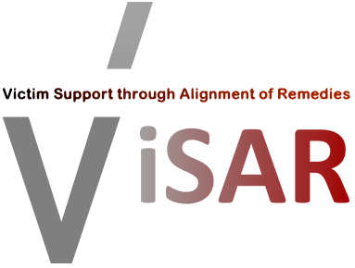
F I N A L S Y M P O S I U M
Victims’ Rights in Europe
and AI Tools for Strengthening Victims’ Rights

24 September 2026
Registration from 09:30 · Programme 10:00 – 17:30 (Greek time)
Hybrid event · Hosted by EPLO, Athens
Polygnotou 2–4, Plaka, Athens, GR-105 55, Greece
Working language: English
The ViSAR Final Symposium brings together project partners, experts and professionals to share the project’s main results and reflect on current and future challenges in the protection of victims’ rights across Europe. The event focuses on the implementation of victims’ rights, victim support and restorative justice, while presenting the experience gained through the national Mutual Exchange Learning Events and the digital and AI-supported tools developed within ViSAR.
▸ Register for the Symposium
Attendance is free · In person or online · Registration required

In partnership with the ViSAR Consortium
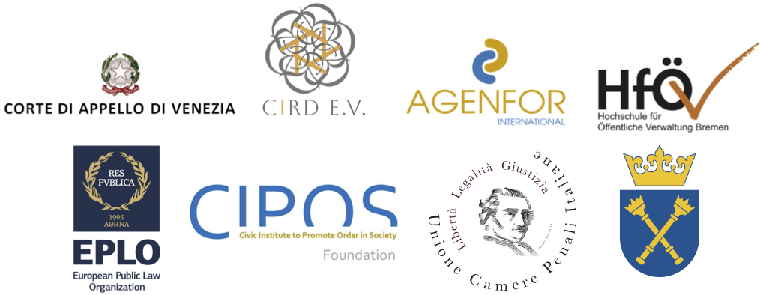
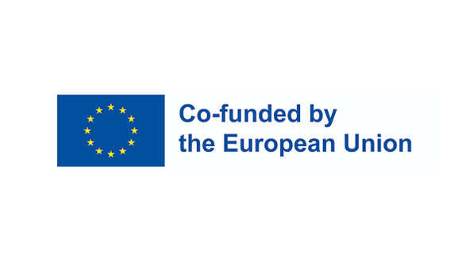
P R O G R A M M E
Final Symposium · 24 September 2026 · Athens (hybrid)
SECTION I — Victims’ Rights in Europe
Coordination: Prof. Vasiliki Artinopoulou (EPLO)
09:30 – 10:00 | Registration  Arrival of participants and networking
10:00 – 10:30 | Opening of the Symposium & Presentation of the ViSAR Project  Welcome remarks, project overview, objectives and outputs.
10:30 – 11:15 | Challenges in Implementing Victims’ Rights  European framework, Victims’ Rights Directive, EPO, Istanbul Convention.  Speakers: Prof. Brian Vanzo — Psychoanalyst, President of CUAV “Centro Ares” for men who commit violence, ViSAR Researcher · Dr. Eleonora Barzan — Clinical and Forensic Psychologist, facilitator in psychoeducational programs, ViSAR Researcher
11:15 – 11:30 | Coffee Break
11:30 – 12:30 | Assessing Implementation Challenges  Findings, comparative reflections and lessons learned from national MELEs.  Speakers: Dr. Konstantinos Panagos — Assistant Professor, Faculty of Law, National and Kapodistrian University of Athens; ViSAR Researcher, EPLO · Dr. Beatrice Maccarini — Criminologist and RJ practitioner, Agenfor International Foundation
12:30 – 13:15 | Victim Support Strategies  Restorative justice, victim protection and domestic violence.  Speaker: Dr. Linda Millington — Lead Practitioner, Kent and Medway Restorative Justice Service
13:00 – 14:15 | Lunch Break
SECTION II — AI Tools for Strengthening Victims’ Rights
Coordination: Sergio Bianchi (Agenfor International)
14:15 – 15:00 | ViSAR Digital Platform  AI-supported platform, avatar system and digital tools.  Speaker: Sergio Bianchi — Agenfor International Foundation
15:00 – 15:45 | Digital Resources for Domestic Violence  Violence Prevention App.  Speaker: Ms. Stefanie Knaab — NGO Gewaltfrei in die Zukunft
15:30 – 15:45 | Coffee Break
15:45 – 17:15 | Round Table  Future perspectives for victim support, training and AI-based tools.  With: Representatives from Italy, Germany, Greece, Poland and Curaçao
17:15 – 17:30 | Closing Remarks  Main conclusions, sustainability and dissemination.  Speakers: JU Representative · Prof. Vasiliki Artinopoulou — Professor of Criminology, Panteion University; Director of the Institute for Crime and Criminal Justice, EPLO
Register: ViSAR Final Symposium registration form

