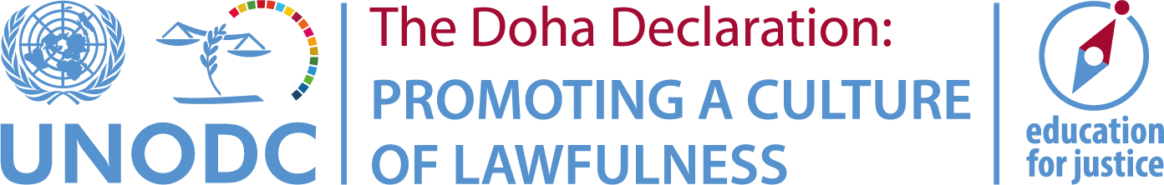
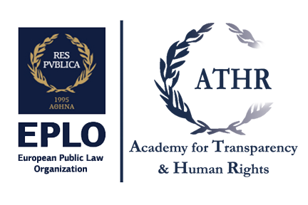

Join our CCPCJ side event!

Fighting Corruption Through Education

Launch of the E4J Anti-Corruption University Modules &
Taking Stock of the E4J Integrity and Ethics University Modules
( http://www.unodc.org/e4j/en/tertiary/integrity-ethics.html )

Tuesday 21 May 2019 @ 9 am
Vienna International Centre, Conference Room M7

In collaboration with over 100 academics from around the world, UNODC’s Education for Justice (E4J) initiative has developed 14 Integrity and Ethics University Modules and is finalizing 14 Anti-Corruption University Modules. The panelists will discuss the impact of the Integrity and Ethics University Modules and launch the Anti-Corruption University Modules.

Opening remarks:
Panagiotis Alexopoulos, Academy for Transparency & Human Rights,
European Public Law Organization
Speakers:
Donna Harris, University of Oxford, UK
“Impact Study of the E4J Modules: Preliminary findings and way forward”
Atanas Dimitrov, University of National and World Economy, Bulgaria
“Personal experiences: Teaching the E4J Modules in Bulgaria”
Leyla Tavernaro-Haidarian, University of Johannesburg, South Africa
“Spreading the good news: Training colleagues to teach the E4J Modules”
Fadi Rabia, Al-Quds University, Palestine
“Insights from co-creating the E4J Modules with the UNODC”
Panagiotis Alexopoulos, Academy for Transparency & Human Rights, EPLO
“Plans for incorporating the E4J Modules in the curriculum”

Closing remarks:
Richard Ever Veizaga Ayala, Chief, Departmental Representative of Cochabamba,
Ministry of Justice and Institutional Transparency, Plurinational State of Bolivia

Moderator: Sigall Horovitz, Corruption and Economic Crimes Branch, UNODC

