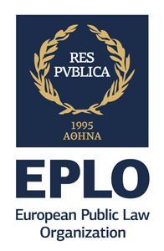


20 August -10 September, 2018
The Academy of
European Public Law

The Academy of
European Public Law
2016 Summer Study Session


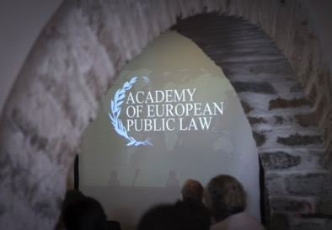
Why Study at the Academy?

- 3 weeks of quality study and at the same time a visit to the most representative parts of the Greek culture and civilization: Athens and Sounion

- Learn from world-class academics from the most prestigious universities of the world

- Keep up-to-date with the most recent curriculum on European Public Law

- Interact with internationally renowned jurists, judges & law academics by attending a unique conference

- Pursue a Diploma level studies (I.I.LL.M) without compromising your personal or professional obligations
About the Academy

Founded in 1995, the Academy is the most historic and established education institution of the European Public Law Organization (EPLO).

The Academy offers 3-week summer study sessions for those interested in furthering their knowledge on the philosophical backdrop of different European national public law systems, as well as on their commonalities and differences.

Students may obtain a Certificate of Attendance for the attendance of one session, or, an Intensive International Master of Laws (I.I.LL.M.) in European Public Law, a diploma level degree, following the attendance of two sessions and the defense of a dissertation.


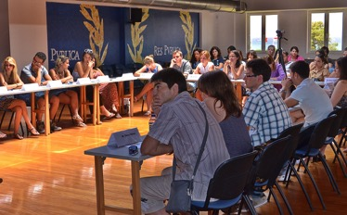




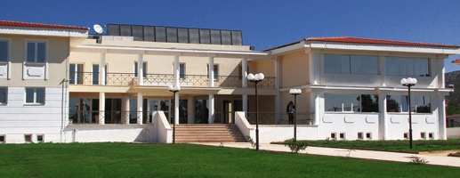

www.eploacademy.eu

www.eploacademy.eu
Eligibility to Apply
The Academy of European Public Law is for those who seek to deepen their knowledge on the reasoning and philosophy of the different national public law systems of European countries, as well as the divergences among them, and obtain either a Certificate of Attendance in European Public Law or an Intensive International LLM (I.I.LL.M). Applicants to both the Certificate program and the I.I.LL.M programs should possess:
1. An Undergraduate degree in law, political science, European studies, international affairs, or any other related field.

2. Proficiency in English

3. An exceptional academic background and/or maintain promising careers.

2018 Program Highlights
The Program is composed of two 1-week intensive teaching sessions and a one Guest Lecture on different topics. At the end of each session, students must undertake an examination, which will be in the form of an essay, marked on a pass/fail or distinction basis. The final session will be held in Sounion where students will attend the Annual Reunion of the European Group of Public Law.

INTENSIVE MODULES:

• Prof. Patricia Jonason (Södertörn University), “The Right to Privacy”
Week I: August 20- August 24

•Prof. Oswald Jansen (Maastricht University), “Developments in law enforcement strategies and powers: the influence of anti-terrorism policies on administrative law”
Week II-III: August 28 - September 3

SEMINAR
A seminar will be delivered by the guest lecturer, Prof. Sabino Cassese, (Justice Emeritus of the Italian Constitutional Court and Emeritus professor at the Scuola Normale Superiore of Pisa) on “Limits of Democracy”.

Fees

Fees for the Academy of European Public Law include a non-refundable 50€ application fee and the program fee of 950€ for the Certificate program and 1900€ for the I.I.L.L.M. The program fee includes:

•Participation for one or two summer sessions
•Certificate of Participation and Completion
•ECTS Diploma Supplement Upon Request
•Non-printed Course Material
•Participation at the European Group of Public Law Conference.

The Early Bird rate is 760€ & 1520€ respectively if students apply by April 27, 2018, under the condition that at least half of the program fee is paid by May 18th, 2018.

For more information on payments, accommodation, meals and transfer packages, please visit the site or contact academy@eplo.eu

Admissions
REQUIRED DOCUMENTS:
1. Completed Application form
2. Payment of non-refundable application fee of 50€ and scanned copy of receipt of payment
3. Current CV, preferably in EuroPass Format
4. Evidence of Current Studies or Current Employment in digital format (scanned copy)
5. A Letter of Recommendation (for I.I.LL.M program only, scanned copy)
6. Cover letter for Scholarship Request (if relevant, in digital format)

APPLICATION PROCEDURE:
1. Before starting the online application, please make sure you have all the requested supporting documents ready for upload
2. Complete the online Application Form
3. Upload all supportive documents when prompted in the form and submit your application.

The facilities in Sounion include:

•A large-scale conference hall •A tennis court
•Four seminar rooms •A volleyball court
•A basketball court •A garden of 30.000 m²
•An outdoor open theater

Live the Best of Greece
The classes will be held at the EPLO premises in Athens (first week) and Sounion-Legraina
(2weeks), near the bay of Cape Sounion and the
Temple of Poseidon, overlooking the Aegean Sea.
The last four days students will be following the works of the EGPL conference that this year will take place in Sounion premises. The EPLO premises in Sounion host the European Public Law Library, one of the largest specialized academic law libraries in Europe. Its corpora on national law cover over 50 countries worldwide.
Accomodation
For students who require assistance with accommodation and transportation, the Academy of European Public Law can offer a package at the following rates:
• 1300€ per person, accommodation in a single room from Sunday 21st of August to Monday, 12th of September
• 1000€ per person, accommodation in a double room from Sunday 21st of August to Monday, 12th of September

These rates include:
• Accommodation in Athens at Athinais Hotel on a bed and breakfast basis from Sunday, 20th of August until Saturday, 26th of August.

• Accommodation in Sounion at Alexander Hotel on a half board basis from Saturday, 26th of August until Sunday, 10th of September.

www.eploacademy.eu

About us:

The European Public Law Organization (EPLO) was established in 2007 in Athens, Greece as an international organization dedicated to the creation and dissemination of knowledge in the area of public law lato sensu, including but not limited to inter alia national, comparative and European public law, human rights law and environmental law for a better generation of lawyers and democratic institutions in Europe and worldwide.

Contact:
European Public Law Organization Athens

16 Achaiou St., Kolonaki
Athens 10 675-GR

2-4 Polygnotou St., Plaka
Athens 10 555- GR

Tel: +30 211 311 0 671
Fax: +30 22920 69813

Websites: www.eplo.int, www.eploacademy.eu

European Public Law Organization Sounion

64th Km Athens-Sounion Ave
Legraina 19 500- GR

